In Chapter 1, we learned how business transactions impact Core Fitness and it’s financials.

While Chapter 1 taught us how individual accounts are impacted, in order to get insight into Core Fitness’s financial health, we need to look at a consolidated view of the fitness studio’s transactions.

In order to get an aggregated picture of the company financials and decision making, we need to collect, analyze and organize the raw transaction data into organized formats. Such set of reports are called **financial statements**

We use Core Fitness’ **financial statements** to get an aggregated picture of the company and can analyze if it is doing well, financially.



## The Accounting Cycle

In order to go from individual transactions to the summary financial statements, **7 steps** are taken.

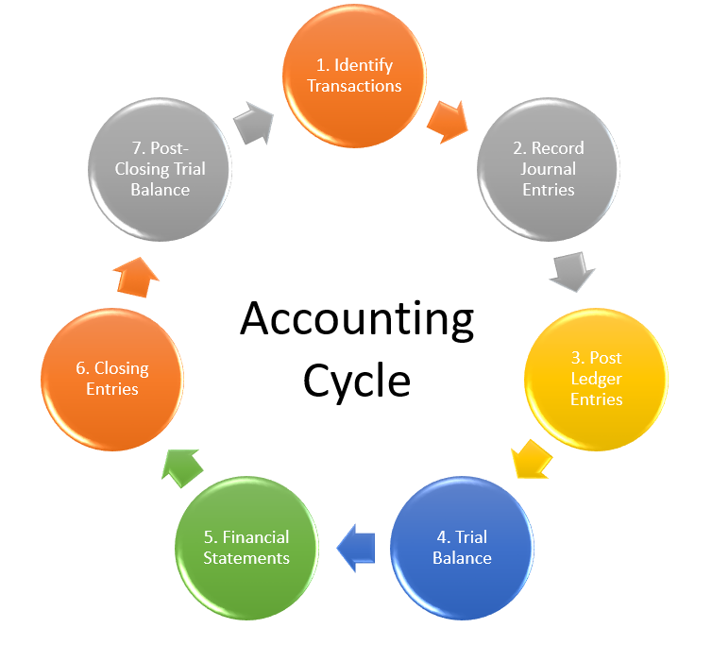

Every company prepares these statements for specific time periods – such as monthly and annually. After each month a new period begins and we restart the 7 steps, so the cycle repeats. This recording of transactions is known as the **Accounting Cycle.**

We completed the first step of **Identifying Transactions** in Chapter 1.

In Chapter 2, we will learn how to complete steps 2 and 3 which involve taking these transactions and recording them in two ways – **Journals and Ledgers.**